Source Data Mapping Approach to CDMV5.4

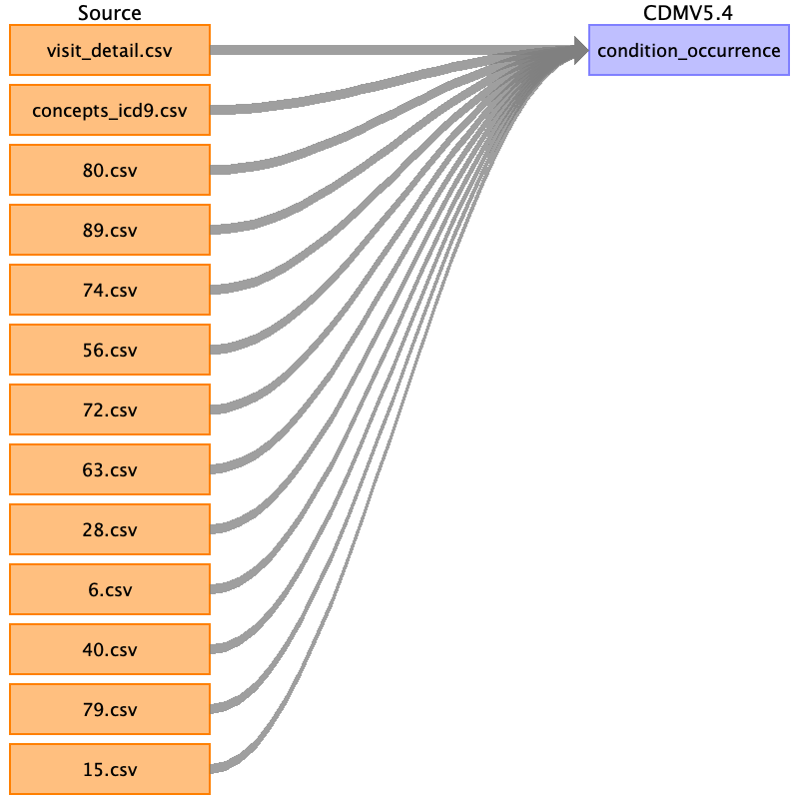

Table name: person

Table name: observation_period

Table name: visit_occurrence

Table name: visit_detail

Table name: condition_occurrence

Reading from 6.csv

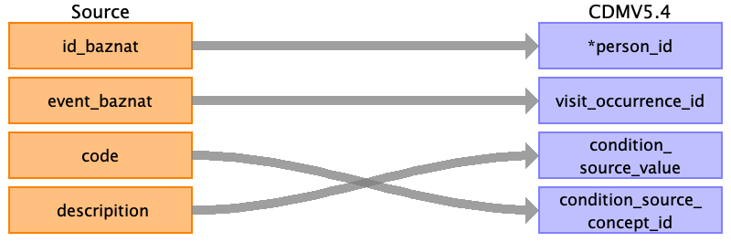

|  |  |  |  |
| --- | --- | --- | --- |
| Destination Field | Source Field | Logic | Comment |
| condition_occurrence_id |  |  | index run |
| person_id | ﻿id_baznat |  |  |
| condition_concept_id |  |  | from experts table or concepts_icd9 |
| condition_start_date |  |  | datetime.date() |
| condition_start_datetime |  |  | record date or from table 89 |
| condition_end_date |  |  |  |
| condition_end_datetime |  |  |  |
| condition_type_concept_id |  |  | 32817 |
| condition_status_concept_id |  |  |  |
| stop_reason |  |  |  |
| provider_id |  |  |  |
| visit_occurrence_id | event_baznat |  |  |
| visit_detail_id |  |  | from table visit_detail |
| condition_source_value | descripition |  |  |
| condition_source_concept_id | code |  | check if the code has a match in the concept_icd9 table |
| condition_status_source_value |  |  |  |

Reading from visit_detail.csv

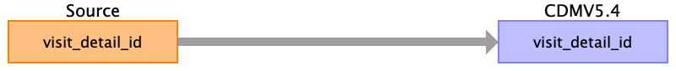

|  |  |  |  |
| --- | --- | --- | --- |
| Destination Field | Source Field | Logic | Comment |
| condition_occurrence_id |  |  | index run |
| person_id |  |  |  |
| condition_concept_id |  |  | from experts table or concepts_icd9 |
| condition_start_date |  |  | datetime.date() |
| condition_start_datetime |  |  | record date or from table 89 |
| condition_end_date |  |  |  |
| condition_end_datetime |  |  |  |
| condition_type_concept_id |  |  | 32817 |
| condition_status_concept_id |  |  |  |
| stop_reason |  |  |  |
| provider_id |  |  |  |
| visit_occurrence_id |  |  |  |
| visit_detail_id | visit_detail_id |  | from table visit_detail |
| condition_source_value |  |  |  |
| condition_source_concept_id |  |  | check if the code has a match in the concept_icd9 table |
| condition_status_source_value |  |  |  |

Reading from concepts_icd9.csv

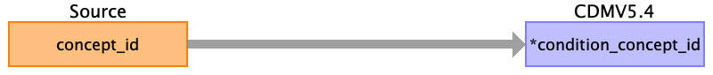

|  |  |  |  |
| --- | --- | --- | --- |
| Destination Field | Source Field | Logic | Comment |
| condition_occurrence_id |  |  | index run |
| person_id |  |  |  |
| condition_concept_id | concept_id |  | from experts table or concepts_icd9 |
| condition_start_date |  |  | datetime.date() |
| condition_start_datetime |  |  | record date or from table 89 |
| condition_end_date |  |  |  |
| condition_end_datetime |  |  |  |
| condition_type_concept_id |  |  | 32817 |
| condition_status_concept_id |  |  |  |
| stop_reason |  |  |  |
| provider_id |  |  |  |
| visit_occurrence_id |  |  |  |
| visit_detail_id |  |  | from table visit_detail |
| condition_source_value |  |  |  |
| condition_source_concept_id |  |  | check if the code has a match in the concept_icd9 table |
| condition_status_source_value |  |  |  |

Reading from 80.csv

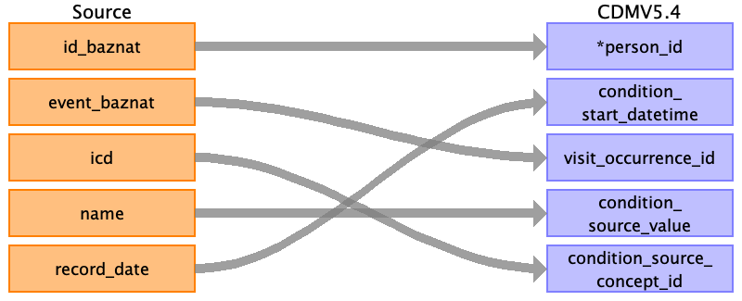

|  |  |  |  |
| --- | --- | --- | --- |
| Destination Field | Source Field | Logic | Comment |
| condition_occurrence_id |  |  | index run |
| person_id | ﻿id_baznat |  |  |
| condition_concept_id |  |  | from experts table or concepts_icd9 |
| condition_start_date |  |  | datetime.date() |
| condition_start_datetime | record_date |  | record date or from table 89 |
| condition_end_date |  |  |  |
| condition_end_datetime |  |  |  |
| condition_type_concept_id |  |  | 32817 |
| condition_status_concept_id |  |  |  |
| stop_reason |  |  |  |
| provider_id |  |  |  |
| visit_occurrence_id | event_baznat |  |  |
| visit_detail_id |  |  | from table visit_detail |
| condition_source_value | name |  |  |
| condition_source_concept_id | icd |  | check if the code has a match in the concept_icd9 table |
| condition_status_source_value |  |  |  |

Reading from 89.csv

Generated

|  |  |  |  |
| --- | --- | --- | --- |
| Destination Field | Source Field | Logic | Comment |
| condition_occurrence_id |  |  | index run |
| person_id |  |  |  |
| condition_concept_id |  |  | from experts table or concepts_icd9 |
| condition_start_date |  |  | datetime.date() |
| condition_start_datetime |  |  | record date or from table 89 |
| condition_end_date |  |  |  |
| condition_end_datetime |  |  |  |
| condition_type_concept_id |  |  | 32817 |
| condition_status_concept_id |  |  |  |
| stop_reason |  |  |  |
| provider_id |  |  |  |
| visit_occurrence_id |  |  |  |
| visit_detail_id |  |  | from table visit_detail |
| condition_source_value |  |  |  |
| condition_source_concept_id |  |  | check if the code has a match in the concept_icd9 table |
| condition_status_source_value |  |  |  |

Reading from 74.csv



|  |  |  |  |
| --- | --- | --- | --- |
| Destination Field | Source Field | Logic | Comment |
| condition_occurrence_id |  |  | index run |
| person_id | ﻿id_baznat |  |  |
| condition_concept_id |  |  | from experts table or concepts_icd9 |
| condition_start_date |  |  | datetime.date() |
| condition_start_datetime | record_date |  | record date or from table 89 |
| condition_end_date |  |  |  |
| condition_end_datetime |  |  |  |
| condition_type_concept_id |  |  | 32817 |
| condition_status_concept_id |  |  |  |
| stop_reason |  |  |  |
| provider_id |  |  |  |
| visit_occurrence_id | event_baznat |  |  |
| visit_detail_id |  |  | from table visit_detail |
| condition_source_value | name |  |  |
| condition_source_concept_id | icd |  | check if the code has a match in the concept_icd9 table |
| condition_status_source_value |  |  |  |

Reading from 56.csv



|  |  |  |  |
| --- | --- | --- | --- |
| Destination Field | Source Field | Logic | Comment |
| condition_occurrence_id |  |  | index run |
| person_id | ﻿id_baznat |  |  |
| condition_concept_id |  |  | from experts table or concepts_icd9 |
| condition_start_date |  |  | datetime.date() |
| condition_start_datetime | record_date |  | record date or from table 89 |
| condition_end_date |  |  |  |
| condition_end_datetime |  |  |  |
| condition_type_concept_id |  |  | 32817 |
| condition_status_concept_id |  |  |  |
| stop_reason |  |  |  |
| provider_id |  |  |  |
| visit_occurrence_id | event_baznat |  |  |
| visit_detail_id |  |  | from table visit_detail |
| condition_source_value | name |  |  |
| condition_source_concept_id | icd |  | check if the code has a match in the concept_icd9 table |
| condition_status_source_value |  |  |  |

Reading from 72.csv



|  |  |  |  |
| --- | --- | --- | --- |
| Destination Field | Source Field | Logic | Comment |
| condition_occurrence_id |  |  | index run |
| person_id | ﻿id_baznat |  |  |
| condition_concept_id |  |  | from experts table or concepts_icd9 |
| condition_start_date |  |  | datetime.date() |
| condition_start_datetime | record_date |  | record date or from table 89 |
| condition_end_date |  |  |  |
| condition_end_datetime |  |  |  |
| condition_type_concept_id |  |  | 32817 |
| condition_status_concept_id |  |  |  |
| stop_reason |  |  |  |
| provider_id |  |  |  |
| visit_occurrence_id | event_baznat |  |  |
| visit_detail_id |  |  | from table visit_detail |
| condition_source_value | name |  |  |
| condition_source_concept_id | icd |  | check if the code has a match in the concept_icd9 table |
| condition_status_source_value |  |  |  |

Reading from 63.csv



|  |  |  |  |
| --- | --- | --- | --- |
| Destination Field | Source Field | Logic | Comment |
| condition_occurrence_id |  |  | index run |
| person_id | ﻿id_baznat |  |  |
| condition_concept_id |  |  | from experts table or concepts_icd9 |
| condition_start_date |  |  | datetime.date() |
| condition_start_datetime | record_date |  | record date or from table 89 |
| condition_end_date |  |  |  |
| condition_end_datetime |  |  |  |
| condition_type_concept_id |  |  | 32817 |
| condition_status_concept_id |  |  |  |
| stop_reason |  |  |  |
| provider_id |  |  |  |
| visit_occurrence_id | event_baznat |  |  |
| visit_detail_id |  |  | from table visit_detail |
| condition_source_value | name |  |  |
| condition_source_concept_id | icd |  | check if the code has a match in the concept_icd9 table |
| condition_status_source_value |  |  |  |

Reading from 28.csv



|  |  |  |  |
| --- | --- | --- | --- |
| Destination Field | Source Field | Logic | Comment |
| condition_occurrence_id |  |  | index run |
| person_id | ﻿id_baznat |  |  |
| condition_concept_id |  |  | from experts table or concepts_icd9 |
| condition_start_date |  |  | datetime.date() |
| condition_start_datetime | record_date |  | record date or from table 89 |
| condition_end_date |  |  |  |
| condition_end_datetime |  |  |  |
| condition_type_concept_id |  |  | 32817 |
| condition_status_concept_id |  |  |  |
| stop_reason |  |  |  |
| provider_id |  |  |  |
| visit_occurrence_id | event_baznat |  |  |
| visit_detail_id |  |  | from table visit_detail |
| condition_source_value | name |  |  |
| condition_source_concept_id | icd |  | check if the code has a match in the concept_icd9 table |
| condition_status_source_value |  |  |  |

Reading from 40.csv



|  |  |  |  |
| --- | --- | --- | --- |
| Destination Field | Source Field | Logic | Comment |
| condition_occurrence_id |  |  | index run |
| person_id | ﻿id_baznat |  |  |
| condition_concept_id |  |  | from experts table or concepts_icd9 |
| condition_start_date |  |  | datetime.date() |
| condition_start_datetime | record_date |  | record date or from table 89 |
| condition_end_date |  |  |  |
| condition_end_datetime |  |  |  |
| condition_type_concept_id |  |  | 32817 |
| condition_status_concept_id |  |  |  |
| stop_reason |  |  |  |
| provider_id |  |  |  |
| visit_occurrence_id | event_baznat |  |  |
| visit_detail_id |  |  | from table visit_detail |
| condition_source_value | name |  |  |
| condition_source_concept_id | icd |  | check if the code has a match in the concept_icd9 table |
| condition_status_source_value |  |  |  |

Reading from 79.csv



|  |  |  |  |
| --- | --- | --- | --- |
| Destination Field | Source Field | Logic | Comment |
| condition_occurrence_id |  |  | index run |
| person_id | ﻿id_baznat |  |  |
| condition_concept_id |  |  | from experts table or concepts_icd9 |
| condition_start_date |  |  | datetime.date() |
| condition_start_datetime | record_date |  | record date or from table 89 |
| condition_end_date |  |  |  |
| condition_end_datetime |  |  |  |
| condition_type_concept_id |  |  | 32817 |
| condition_status_concept_id |  |  |  |
| stop_reason |  |  |  |
| provider_id |  |  |  |
| visit_occurrence_id | event_baznat |  |  |
| visit_detail_id |  |  | from table visit_detail |
| condition_source_value | name |  |  |
| condition_source_concept_id | icd |  | check if the code has a match in the concept_icd9 table |
| condition_status_source_value |  |  |  |

Reading from 15.csv



|  |  |  |  |
| --- | --- | --- | --- |
| Destination Field | Source Field | Logic | Comment |
| condition_occurrence_id |  |  | index run |
| person_id | ﻿id_baznat |  |  |
| condition_concept_id |  |  | from experts table or concepts_icd9 |
| condition_start_date |  |  | datetime.date() |
| condition_start_datetime |  |  | record date or from table 89 |
| condition_end_date |  |  |  |
| condition_end_datetime |  |  |  |
| condition_type_concept_id |  |  | 32817 |
| condition_status_concept_id |  |  |  |
| stop_reason |  |  |  |
| provider_id |  |  |  |
| visit_occurrence_id | event_baznat |  |  |
| visit_detail_id |  |  | from table visit_detail |
| condition_source_value | descripition |  |  |
| condition_source_concept_id | code |  | check if the code has a match in the concept_icd9 table |
| condition_status_source_value |  |  |  |

Table name: drug_exposure

Table name: procedure_occurrence

Table name: device_exposure

Table name: measurement

Table name: observation

Table name: death

Table name: note

Table name: note_nlp

Table name: specimen

Table name: fact_relationship

Table name: location

Table name: care_site

Table name: provider

Table name: payer_plan_period

Table name: cost

Table name: drug_era

Table name: dose_era

Table name: condition_era

Table name: episode

Table name: episode_event

Table name: metadata

Table name: cdm_source

Table name: cohort

Table name: cohort_definition

Appendix: source tables

Table: visit_detail.csv

|  |  |  |  |
| --- | --- | --- | --- |
| Field | Type | Most freq. value | Comment |
| visit_detail_id | INT |  |  |
| person_id | INT |  |  |
| visit_detail_concept_id | INT |  |  |
| visit_detail_start_date | INT |  |  |
| visit_detail_start_datetime | INT |  |  |
| visit_detail_end_date | INT |  |  |
| visit_detail_end_datetime | INT |  |  |
| visit_detail_type_concept_id | INT |  |  |
| provider_id | INT |  |  |
| care_site_id | INT |  |  |
| visit_detail_source_value | INT |  |  |
| visit_detail_source_concept_id | INT |  |  |
| admitted_from_concept_id | INT |  |  |
| admitted_from_source_value | INT |  |  |
| discharged_to_source_value | INT |  |  |
| discharged_to_concept_id | INT |  |  |
| preceding_visit_detail_id | INT |  |  |
| parent_visit_detail_id | INT |  |  |
| visit_occurrence_id |  |  |  |

Table: concepts_icd9.csv

|  |  |  |  |
| --- | --- | --- | --- |
| Field | Type | Most freq. value | Comment |
| concept_id | INT |  |  |
| concept_name | INT |  |  |
| domain_id | INT |  |  |
| vocabulary_id | INT |  |  |
| concept_class_id | INT |  |  |
| standard_concept | INT |  |  |
| concept_code | INT |  |  |
| valid_start_date | INT |  |  |
| valid_end_date | INT |  |  |
| invalid_reason | INT |  |  |

Table: 80.csv

|  |  |  |  |
| --- | --- | --- | --- |
| Field | Type | Most freq. value | Comment |
| ﻿id_baznat | INT |  |  |
| event_baznat | INT |  |  |
| unit | INT |  |  |
| side | INT |  |  |
| sort | INT |  |  |
| recurrent | INT |  |  |
| mp | INT |  |  |
| sp | INT |  |  |
| relevant_since_date | INT |  |  |
| description | INT |  |  |
| icd | INT |  |  |
| family_relation | INT |  |  |
| name | INT |  |  |
| remark | INT |  |  |
| record_date | INT |  |  |

Table: 89.csv

|  |  |  |  |
| --- | --- | --- | --- |
| Field | Type | Most freq. value | Comment |
| ﻿id_baznat | INT |  |  |
| mother_id_baznat | INT |  |  |
| hosp_entry_date | INT |  |  |
| hosp_exit_date | INT |  |  |
| event_baznat | INT |  |  |
| emg_event_baznat | INT |  |  |
| cham_hosp_entry_date | INT |  |  |
| cham_hosp_exit_date | INT |  |  |
| age_category | INT |  |  |

Table: 74.csv

|  |  |  |  |
| --- | --- | --- | --- |
| Field | Type | Most freq. value | Comment |
| ﻿id_baznat | INT |  |  |
| event_baznat | INT |  |  |
| unit | INT |  |  |
| field | INT |  |  |
| side | INT |  |  |
| sort | INT |  |  |
| recurrent | INT |  |  |
| mp | INT |  |  |
| sp | INT |  |  |
| relevant_since_date | INT |  |  |
| description | INT |  |  |
| icd | INT |  |  |
| family_relation | INT |  |  |
| name | INT |  |  |
| remark | INT |  |  |
| record_date | INT |  |  |

Table: 56.csv

|  |  |  |  |
| --- | --- | --- | --- |
| Field | Type | Most freq. value | Comment |
| ﻿id_baznat | INT |  |  |
| event_baznat | INT |  |  |
| unit | INT |  |  |
| side | INT |  |  |
| sort | INT |  |  |
| recurrent | INT |  |  |
| mp | INT |  |  |
| sp | INT |  |  |
| relevant_since_date | INT |  |  |
| description | INT |  |  |
| icd | INT |  |  |
| family_relation | INT |  |  |
| name | INT |  |  |
| remark | INT |  |  |
| record_date | INT |  |  |

Table: 72.csv

|  |  |  |  |
| --- | --- | --- | --- |
| Field | Type | Most freq. value | Comment |
| ﻿id_baznat | INT |  |  |
| event_baznat | INT |  |  |
| unit | INT |  |  |
| side | INT |  |  |
| sort | INT |  |  |
| recurrent | INT |  |  |
| mp | INT |  |  |
| sp | INT |  |  |
| relevant_since_date | INT |  |  |
| description | INT |  |  |
| icd | INT |  |  |
| family_relation | INT |  |  |
| name | INT |  |  |
| remark | INT |  |  |
| record_date | INT |  |  |

Table: 63.csv

|  |  |  |  |
| --- | --- | --- | --- |
| Field | Type | Most freq. value | Comment |
| ﻿id_baznat | INT |  |  |
| event_baznat | INT |  |  |
| unit | INT |  |  |
| field | INT |  |  |
| side | INT |  |  |
| sort | INT |  |  |
| recurrent | INT |  |  |
| mp | INT |  |  |
| sp | INT |  |  |
| relevant_since_date | INT |  |  |
| description | INT |  |  |
| icd | INT |  |  |
| name | INT |  |  |
| remark | INT |  |  |
| record_date | INT |  |  |

Table: 28.csv

|  |  |  |  |
| --- | --- | --- | --- |
| Field | Type | Most freq. value | Comment |
| ﻿id_baznat | INT |  |  |
| event_baznat | INT |  |  |
| unit | INT |  |  |
| field | INT |  |  |
| side | INT |  |  |
| sort | INT |  |  |
| recurrent | INT |  |  |
| mp | INT |  |  |
| sp | INT |  |  |
| relevant_since_date | INT |  |  |
| description | INT |  |  |
| icd | INT |  |  |
| name | INT |  |  |
| remark | INT |  |  |
| record_date | INT |  |  |

Table: 6.csv

|  |  |  |  |
| --- | --- | --- | --- |
| Field | Type | Most freq. value | Comment |
| ﻿id_baznat | INT |  |  |
| event_baznat | INT |  |  |
| unit | INT |  |  |
| code | INT |  |  |
| descripition | INT |  |  |
| main | INT |  |  |
| chronic | INT |  |  |
| status | INT |  |  |
| location | INT |  |  |
| duration | INT |  |  |
| severity | INT |  |  |
| day | INT |  |  |
| month | INT |  |  |
| year | INT |  |  |

Table: 40.csv

|  |  |  |  |
| --- | --- | --- | --- |
| Field | Type | Most freq. value | Comment |
| ﻿id_baznat | INT |  |  |
| event_baznat | INT |  |  |
| unit | INT |  |  |
| side | INT |  |  |
| sort | INT |  |  |
| recurrent | INT |  |  |
| mp | INT |  |  |
| sp | INT |  |  |
| relevant_since_date | INT |  |  |
| description | INT |  |  |
| icd | INT |  |  |
| family_relation | INT |  |  |
| name | INT |  |  |
| remark | INT |  |  |
| record_date | INT |  |  |

Table: 79.csv

|  |  |  |  |
| --- | --- | --- | --- |
| Field | Type | Most freq. value | Comment |
| ﻿id_baznat | INT |  |  |
| event_baznat | INT |  |  |
| unit | INT |  |  |
| field | INT |  |  |
| side | INT |  |  |
| sort | INT |  |  |
| recurrent | INT |  |  |
| mp | INT |  |  |
| sp | INT |  |  |
| relevant_since_date | INT |  |  |
| description | INT |  |  |
| icd | INT |  |  |
| family_relation | INT |  |  |
| name | INT |  |  |
| remark | INT |  |  |
| record_date | INT |  |  |

Table: 15.csv

|  |  |  |  |
| --- | --- | --- | --- |
| Field | Type | Most freq. value | Comment |
| ﻿id_baznat | INT |  | index run |
| event_baznat | INT |  |  |
| unit | INT |  |  |
| code | INT |  |  |
| descripition | INT |  |  |
| main | INT |  |  |
| chronic | INT |  |  |
| status | INT |  |  |
| location | INT |  |  |
| duration | INT |  |  |
| severity | INT |  |  |
| day | INT |  |  |
| month | INT |  |  |
| year | INT |  |  |